|  |  |
| --- | --- |
| Exp no:4 | Series and parallel connection |
| Date:  04-11-2021 |

# Aim:

To study the properties of series and parallel connection.

# Required tools:

LTspice software tool

# Theory:

**Series Circuit:**

In a series circuit, the components are connected end-to-end in a line to form a single path through which current can flow. The defining characteristic of a series circuit is that there is only one path for current to flow.

Total Resistance, RT = R1+R2+R3

Total Current, IT = [VS/(R1+R2+R3)]

# Circuit Diagram:

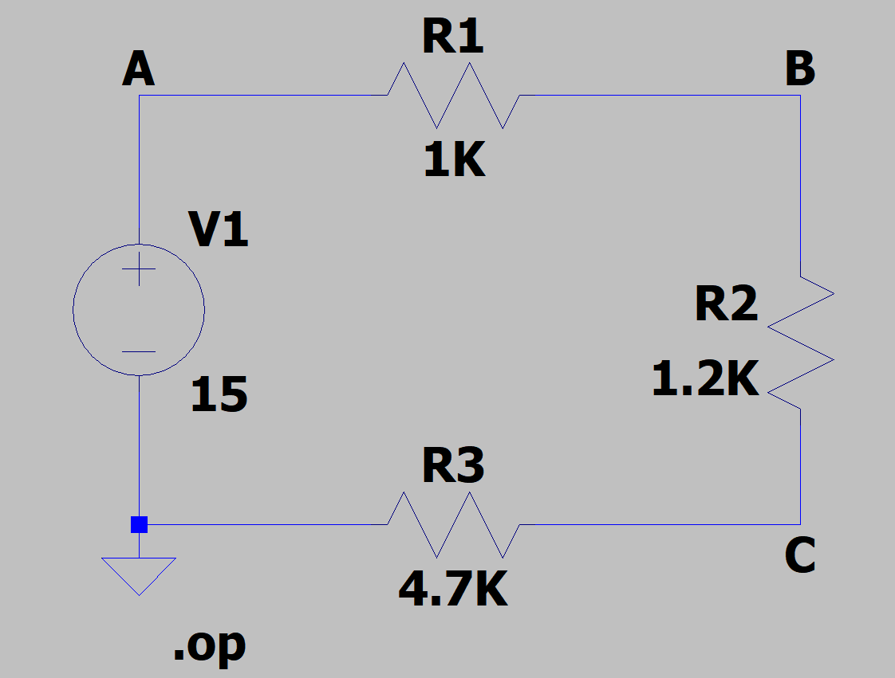

**Parallel Circuit:**

In a parallel circuit, all components are connected across each other’s leads. There are many paths for current flow, but only one voltage across all components. The defining characteristic of a parallel circuit is that all components are connected between the same set of electrically common points.

Total Resistance, (1/RT) = [(1/R1) +(1/R2) +(1/R3)]

Total Current, IT = {VS/[(1/R1) +(1/R2) +(1/R3)]}

# Circuit Diagram:

# 

**Procedure:**

1. Draw the series and parallel circuits in the LT Spice schematic.
2. Apply the voltage and resistance values.
3. Label the nodes at appropriate places in the circuit.
4. Go to simulate tab and select edit simulation command
5. Select operating point analysis in the edit simulation command.
6. Run the simulation
7. Calculate the potential difference across each resistor and check for VS=V1+V2+V3
8. Calculate the current through each resistor and check for IT=I1+I2+I3

**Theoretical calculations:**

Calculate the current through each resistor and check for IT=I1+I2+I3

I(R1) =0.015 A

I(R2) =0.0125 A

I(R3) =0.00319149 A

IT = **0.0306915 A**

For Vs=V1+V2+V3

V(R1) = V(a) – V(b) = 15 – 12.8621 = 2.1740 V

V(R2) = V(b) – V(c) = 12.8621 – 10.2174 = 2.6087 V

V(R3) = V(b) – 0 = 10.2174 – 0 = 10.2174 V

VS= V(R1) + V(R2) + V(R3) = **15 V**

**Comparison of theoretical values to the simulated values:**

|  |  |  |
| --- | --- | --- |
|  | Theoretical value | Simulated value |
| VS (volt) | 15 | 15 |
| IT (mA) | 0.0306915 | 0.0306915 |

**Result:**

The properties of series and parallel circuits are studied through simulation and verified successfully.

**Inferences:**

The theoretical value is the same as the simulated value and hence verified successfully.



Faculty signature:

Marks:

Student signature: